UCI ESSL Virtual Server Configuration

**Outline:**

The Experimental Social Science Laboratory (ESSL) is a computer laboratory for the experimental study of individual and interactive decision making.

Located at SBSG 1240, the laboratory currently hosts computer-based experiments with student subjects. The 40 workstations on the local network of the lab support these experiments.

Currently, ESSL is closed in compliance with UCI’s COVID-19 measures.

The virtual server configuration proposed here aims to replace the one discrete applications server that is currently used to host experiments. In its stead a Kubernetes-based server cluster of 5 machines and a dedicated data store machine will share and spread out the workload generated by the experiments.

In addition to the re-dedicated applications server, the other five implicated machines are already available in the lab too. Furthermore, the proposed re-configuration is liable to yield a much higher utilization of all six machines than has been observed in the past.

The new configuration vastly enhances the performance of the ESSL. In the mid-term (after easing of COVID-19 measures), the reconfigured lab will enable researchers to host large-scale decision-making experiments and for this purpose link workstations in multiple locations within and/or outside the UCI-intranet.

The proposed, Kubernetes based virtualization of the ESSL is highly innovative and not currently supported at any other experimental decision-making lab as far as we are aware.

In the near-term, (subject to COVID-19 measures) the added capabilities allow researchers to conduct conventional-size experiments simultaneously in multiple locations across the UCI-campus. And as this would greatly help to be compliant with the mandated social-distancing rules, it would potentially enable us to reopen the ESSL lab while COVID-19 measures are still in place.

As already stated, the proposed server-cluster configuration can be fully realized using the hardware that is currently available at the ESSL lab. Rather than investing in additional HW, implementing the proposed server cluster requires familiarity with Kubernetes and associated technologies such as Helm Chart scripting.

We expect the project to require no more than a week of work for a Kubernetes-expert, where most work shall be carried out remotely and not requiring physical access to the ESSL.

In the remainder of this document, we provide a more detailed description of the current server configuration at ESSL and of the proposed virtual server configuration, as well as an inventory of available hardware.

**Current Server Configuration:**

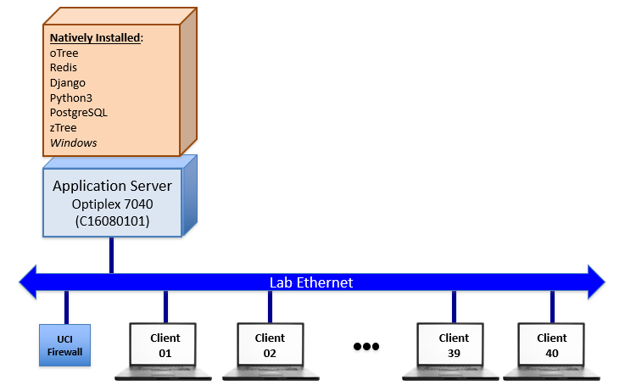

The current server configuration relies on a single Dell Optiplex7040 machine that hosts experimental software supporting 40 client machines across the local ESSL Ethernet. The application server operates on Windows Server 2012.

The experimental software most commonly used at ESSL is oTree, a dedicated software based on Python/Django, REDIS and PostgreSQL.

An older software, zTree, is mostly used for teaching/instruction.

Currently, all researchers deploy their software from a single user account. The simultaneous use of zTree and oTree leads to issues operating the server. While zTree is not being updated and only available on Windows, the current oTree-software package is optimized for Debian/Linux. Furthermore, the most recent Windows implementation of oTree is not compliant with UCI cybersecurity guidelines.

**Virtual Server Configuration:**

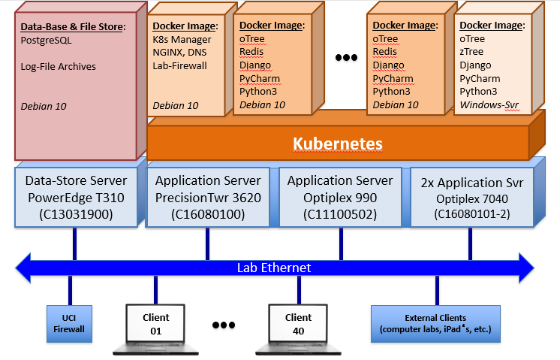

The virtual server configuration will rely on an application server-clsuter that will be implemented using five machines (2x Dell Optiplex7040, Dell Optiplex 990, Dell Precision Tower 3620). One additional machine (Dell Power Edge T310) will be used as a data store.

All machines will operate on Debian 10 allowing for the virtual server-cluster to be orchestrated using Kubernetes.

The experimental software used will continue to be oTree. zTree will continue to be available for instruction.

Researchers and instructors will deploy their software through personalized docker images.

Three different types of docker images will be made available for different purposes. Only one docker image will be active at any given point in time.

The “production” image will be Debian 10-operated, and it will contain the necessary software and command sufficient resources in the server cluster to host conventional experiments (40 students on the local workstations).

The “instructor” image will be Windows-server based and it will contain the software necessary to teach using zTree and oTree (i.e., this amounts to a restricted oTree development-server configuration).

We estimate that around 10 instances of these two kinds will be hosted on the virtual server.

In addition, there will be a single “experimental” docker image. This docker image will contain the same software as the “production” image, but it will command enhanced resources, suitable to conduct large-scale experiments using externally connected clients inside and outside of the UCI-intranet (approx. 1000 students). The UCI-firewall will need to be adjusted in accordance with these added functions.

Finally, the data-store machine will ensure that experimental data and other sensitive files can be effectively shielded from and protected against unauthorized access, even while external clients are connected.

# Inventory of Available Machines

The specifications of the Dell hardware documented here are based on the manufacturer’s record at the respective date of shipment to UCI.

**Optiplex 7040 I7-7600**

|  |  |
| --- | --- |
| *Processor Details:* | eight-core, 3.4 GHz |
| *Cache Memory:* | 4x 2 MB |
| *RAM Memory:* | 2x 8 GB (max. 32 GB) |
| *Mass Storage:* | HDA / SSD drives supported |

**Optiplex 990**

|  |  |
| --- | --- |
| *Processor Details:* | quad-core, 3.4 GHz |
| *Cache Memory:* | 2x 3 MB |
| *RAM Memory:* | 8 GB |
| *Mass Storage:* | 500 GB HDA drive |

**Precision Tower 3620 I3-6100**

|  |  |
| --- | --- |
| *Processor Details:* | quad-core, 3.7 GHz |
| *Cache Memory:* | 4x 2 MB |
| *RAM Memory:* | 2x 4 GB (max. 64 GB) |
| *Mass Storage:* | 1.0 TB HDA drive |

**Power Edge T310**

|  |  |
| --- | --- |
| *Processor Details:* | quad-core, 3.06 GHz |
| *Cache Memory:* | 8 MB |
| *RAM Memory:* | 8 GB (max. 32 GB) |
| *Mass Storage:* | 600 GB SAS or SATA internal drives SAS, SATA, SSD as hot-plug drives |